(Title)

Ashil Sayyed Farahmand

Thesis submitted to the faculty of the Virginia Polytechnic Institute and State University in partial fulfillment of the requirements for the degree of

Master of Science
In
Electrical Engineering

Lamine Mili
Shinya Kikuchi
Daniel Stilwell

January 2008
Falls Church, VA

Keywords: collision avoidance, EKF, extended kalman filter, AVCS, advanced vehicle control systems, ITS, intelligent transportation systems

Copyright (Optional)
(Title)

Ashil Sayyed Farahmand

ABSTRACT

(Enter abstract here)

Acknowledgements

Contents

Acknowledgements iii
Contents iv
List of Figures vi
List of Tables vii
Acronyms viii
Chapter 1 - Introduction ix
1.1 Background ix
1.2 Problems/Limitations ix
1.3 Thesis Overview ix
Chapter 2 - Literature Review xi
2.1 Radar xi
2.2 Optical xi
2.3 Cooperative Collision Avoidance \ MAS(write as separate section?) xi
2.4 Other (Ships, Planes, Robots) xi
Chapter 3 - Vehicle Engine and Powertrain Model xii
3.1 Principles of Automobile Engines and Powertrains xii
3.2 State Space Modeling xiv
3.2.1 Control Variables xiv
3.2.2 State Variables xvi
Chapter 4 - Linearization, Discretization, and the Extended Kalman Filter for Vehicle Modeling xxiii
4.1 Kalman Filter for Linear Model xxiii
4.1.1 Prediction xxv
4.1.2 Correction\Update xxvi
4.2 Extended Kalman Filter xxvi
4.2.1 Prediction xxix
4.2.2 Correction\Update xxix
4.3 Numerical Integration Techniques xxix
4.3.1 Euler Method xxix
4.3.2 Runge Kutta Method xxix
4.4 Discretization and Linearization Methods (162 Grewal) xxix
Chapter 5 - Vehicle Network xxx
5.1 Wireless Networking Technologies (VANETs) xxx
5.2 Cooperative Vehicle Optimization xxx
5.2.1 Sparse Traffic xxx
5.2.2 Dense Traffic xxx
Chapter 6 - Stability xxxi
6.1 Vehicle Model Stability xxxi
6.1.1 Equilibrium Points xxxi
6.1.2 Limit Cycles xxxi
6.2 Vehicle Optimization Algorithm Stability xxxi
Chapter 7 - Simulation Results xxxii
7.1 Vehicle Model Parameters xxxii
7.2 Determining the Brake Constant of Proportionality xxxii
7.3 Determining Deceleration as a Function of Brake Angle xxxii
7.4 Simulations of Sparse Traffic Optimization Algorithm xxxii
Chapter 8 - Conclusions xxxiii
Chapter 9 - References xxxiv

List of Figures

Figure 1.1: A Roundabout ix
Figure. 3.1: Normalized Throttle Characteristics with respect to Throttle Angle, plot of actual data and piecewise continuous fit copied from [1], plot of approximate fit overlaid. xv
Figure. 3.2: Definition of Steering Angle xvi
Figure 3.3: Normalized Pressure Influence Function as a function of the Pressure Ratio. Plot obtained from [1]. xviii

List of Tables

Acronyms
AFI - normalized air fuel influence function
AFR - air/fuel ratio
DSRC - dedicated short-range communications
EFI - electronic fuel injection
EKF - extended kalman filter
MBT - minimum spark advance for best torque
PR - pressure ratio
PRI - normalized pressure influence function
TC - normalized throttle characteristics
SA - spark advance/retard from top dead center
SI - normalized spark influence function

Chapter 1 - Introduction

1.1 Background
The invention of the automobile has allowed people to travel long distances at an unprecedented rate. Initially, vehicle ownership was limited to the rich. However, once mass production began in the 20th century, automobile ownership skyrocketed. The resulting traffic increase and contention at road junctions inspired the creation of new devices to prevent vehicle collisions. Roundabouts, stop signs, yield signs, and traffic signals began to be installed at intersections.

Roundabouts - how work, when to install them, different types

Figure 1.1: A Roundabout

Yield and Stop signs - how stop signs work, when to install them, when to upgrade to light

Traffic signal - timed, semi-actuated, fully actuated, when to install

1.2 Problems/Limitations
The existing intersection control devices are no good because they don't adapt.

1.3 Thesis Overview

(say something about coupled kalman filters)
The research conducted in this thesis seeks to improve upon the performance of current intersection control devices, specifically, traffic signals, stop signs, and yield signs, by proposing a decentralized, adaptive, cooperative collision avoidance system that acts as a traffic signal in dense traffic and as a yield sign in sparse traffic.

In an effort to improve upon other proposed collision avoidance systems that use linear, ideal models, each vehicle is modeled as a nonlinear five state variable model that accounts for the vehicle's physical characteristics and internal engine parameters. The system has each vehicle measure its own state information using sensors. The state information of other vehicles is obtained by receiving data through a wireless communication link. An Extended Kalman Filter is then used to achieve a more precise estimate of the state information from these noisy measurements. The filtered state information is used to determine the optimal trajectory each vehicle should take to minimize the average delay of the vehicles in the intersection.
Chapter 2 - Literature Review

2.1 Radar

2.2 Optical

2.3 Cooperative Collision Avoidance \ MAS(write as separate section?)

2.4 Other (Ships, Planes, Robots)

Chapter 3 - Vehicle Engine and Powertrain Model

The first section of this chapter is intended to provide the reader a presentation of the physical operation of automobile engines and power trains. It is intended to be not a thorough discussion of all internal devices but to provide a sufficient background for understanding this thesis. The following section will present the differential equations governing the dynamics of the vehicle.

3.1 Principles of Automobile Engines and Powertrains
Conventional automobiles generate vehicle motion by burning a mixture of fuel and air. The internal combustion engine is responsible for converting the chemical energy of fuel into vehicle kinetic energy. The power train converts the output of the engine to the appropriate torque and rotational speed before transferring the power to the wheels. This section will provide a detailed discussion of how this process occurs.

The conversion process begins at the throttle. It adjusts the throttle valve which directly controls the amount of air being allowed into the engine's intake manifold. The intake manifold is responsible for regulating airflow to the individual engine cylinders. In naturally-aspirated engines, the pressure of the intake manifold never exceeds the ambient atmospheric pressure. (Discuss turbo + supercharging?) The pressure difference creates a stream of air through the manifold to the cylinders.

(Talk about engine cycle? intake/compression/power/exhaust) (If discussing cylinder configurations, insert here) The engine cylinders are the location where fuel combustion occurs. The cylinders receive air through a valve from the intake manifold. (Discuss fuel injection methods?) The electronic fuel injection (EFI) system mixes the fuel with the air prior to combustion. The type of EFI determines when the fuel is mixed with air. In sequential EFI (also known as multi-port fuel injection), fuel is injected at the exit of the intake manifold as air enters each cylinder for combustion.

The EFI system is also tasked with deciding the amount of fuel to inject. Using an oxygen sensor to measure the composition of gases in the exhaust, it adjusts the amount of fuel to achieve the optimal air/fuel ratio (AFR) during combustion. In terms of mass, an AFR of 14.7:1 results in complete combustion of air and fuel assuming the fuel is pure heptane. Different AFRs may be desired for a variety of reasons depending on the operating conditions.

After combustion occurs in the cylinders, the linear-reciprocating motion of the pistons is converted to rotational motion using a crankshaft. The crankshaft then connects to a flywheel. The flywheel acts as a stabilizing mechanism by smoothing the discrete firings of the pistons into a more continuous rotation. The engine angular velocity and output torque at the flywheel are often inappropriate for direct application to the wheels. The conversion to more appropriate values is performed by the transmission.

The transmission is composed of a gear box and typically in automatic transmissions a torque converter. The torque converter provides fluid coupling and increased torque during initial acceleration. It is composed of at least three rotating elements: a pump, a turbine, and a stator. The input of the converter, the pump, is directly connected to the engine and rotates at engine speed. The output of the converter, the turbine, is connected to the wheels through the gear box. The stator sits between the pump and turbine. When there is a substantial difference between the pump and turbine rotational velocities (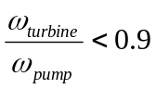), the torque converter is in converter mode. In this mode, the torque converter provides torque multiplication to the output by acting as an additional gear. When the pump and turbine angular velocities are nearly equivalent, the torque converter locks and is in fluid coupling mode [1]. The fluid coupling increases the fuel efficiency of the vehicle. Similar to the function of the flywheel, the fluid coupling also smoothes the rotational speed applied from the pistons to the wheels [Wikipedia].

The gear box of a typical car has four or five gears of fixed size. In an automatic transmission, the vehicle adjusts gears by itself. (Talk about different transmission types?) The gears are sized so that high torque is transferred to the wheels during low velocities and high rotational speed during high velocities. The highest gear is often called the overdrive gear. It significantly increases fuel efficiency at high speeds. When first introduced, the overdrive was a different device housed separately from the rest of the gears but in current vehicles the term is simply used to refer to the highest gear.

3.2 State Space Modeling
The state space vehicle model is based on tabulated data for a 1990 Lincoln Town Car. The model is basically a form of the 3 state variable model derived in [1] with portions from other sources. The vehicle modeled herein is a typical 6 cylinder, front-wheel drive car with a Ford AOD, continuous, four-stroke, spark-ignition engine. This model expands upon the original model and uses 3 control and 5 state variables.

3.2.1 Control Variables
The model's control variables represent the accelerator, brake, and steering wheel. The variables and their notations are shown in Table 3.1.
Table 3.1: Control Variables and Associated Notations.
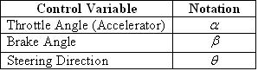

The throttle directly controls the air entering the intake manifold. Since the actual relationship between the two variables is highly nonlinear, an approximate fit based on empirical data is used. The approximate fitted normalized throttle characteristic is defined as
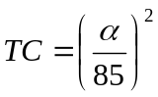. (1)

The effect of the throttle angle on the mass of air entering the intake manifold is shown in Fig. 3.1.

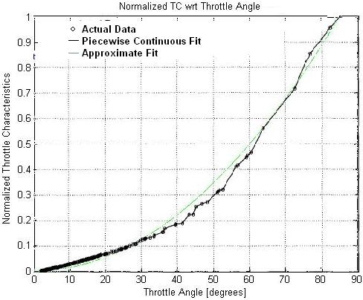

Figure. 3.1: Normalized Throttle Characteristics with respect to Throttle Angle, plot of actual data and piecewise continuous fit copied from [1], plot of approximate fit overlaid.

The brakes control the amount of pressure applied by the brake pads to the wheels. When the brakes are engaged, a torque opposing the motion of the car is created. In conventional vehicles, this causes the vehicle to dissipate energy in the form of heat and decelerate. Through simulations on the state space vehicle model used in this thesis, it was found that
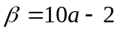 (2)

where  is in degrees and is the deceleration rate in m/s.

The steering direction controls the destination of the vehicle. Like the angles of the unit circle, it has been defined as the angle from the positive x₁ axis as shown in Fig. 3.2.

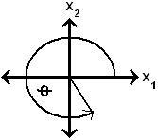

Figure. 3.2: Definition of Steering Angle

3.2.2 State Variables
The state variables of the vehicle are of a number of five; these include the x₁-coordinate position, x₂-coordinate position, mass of air in the intake manifold, engine angular velocity, and brake torque. The variables along with their notations are shown in Table 3.2.
Table 3.2: State Variables and Associated Notations
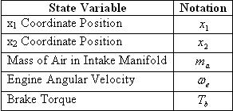

Each vehicle determines its position using GPS. When vehicles come within wireless communication range, each periodically shares its states along with other necessary information with the others. Since these measurements are noisy and communication packets may be lost in transit, it is useful to independently track other vehicles' positions by using velocity for comparison with the GPS measurements. This is carried out as follows: the velocity of a vehicle is given by
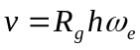, (3)

where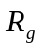 is the gear reduction ratio, a gear-dependent constant, and h is the effective tire radius. Using this equation, it follows that the differential equations for the x₁ and x₂ positions are given by
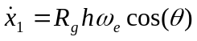, (4)
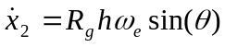. (5)

The differential equation for the next state variable, the mass of air in the intake manifold, is given by
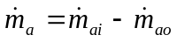, (6)

where 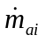 and 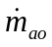 are the mass flow rates of air in and out of the intake manifold. The mass flow rate of air into the intake manifold is dependent on the throttle angle and the pressure difference between the atmosphere and the intake manifold. These dependencies are reflected in its equation
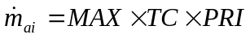. (7)

MAX, a vehicle-dependent constant, is defined as the maximum flow rate of air corresponding to a fully opened throttle valve. The effect of the throttle angle is represented by the normalized throttle characteristic defined in Equation 1. PRI, the normalized pressure influence function, represents the effect the pressure difference has on the incoming mass flow rate. A plot of 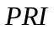 for the specific vehicle used in this thesis is shown in Fig. 3.3.
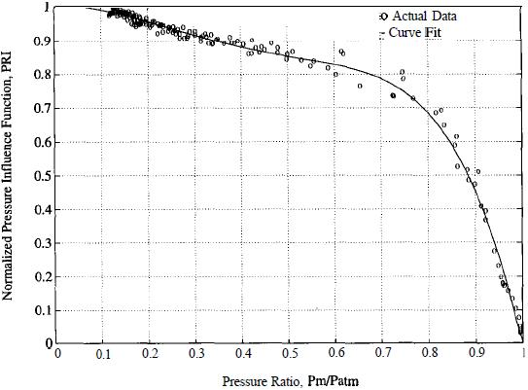

Figure 3.3: Normalized Pressure Influence Function as a function of the Pressure Ratio. Plot obtained from [1].

Due to its nonlinear nature, the curve fit in Figure 3.3 has been used. Its functional form is given by the polynomial
(8)

where 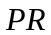 is the pressure ratio. is defined as the ratio between the pressure in the intake manifold and the atmosphere and is given by
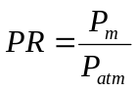. (9)

Using the Ideal Gas Law, the manifold pressure is given by
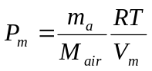, (10)

where  is the ideal gas constant, is the manifold temperature, 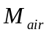 is the molecular mass of air, and 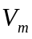 is the volume of the intake manifold.

Now that 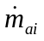 has been analyzed, the differential equations governing the mass flow rate of air exiting the manifold will be studied. Since the air leaving the manifold is directly used for combustion, its mass is dependent on the amount of work the engine is performing. The differential equation for the mass flow rate of air leaving the intake manifold is
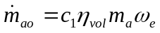, (11)

where 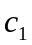 is a physical constant and 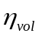 is the volumetric efficiency [1]. is given by
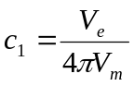, (12)

where 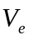 is the constant engine displacement. The volumetric efficiency describes the engine's ability to draw fresh air into the cylinders for combustion. It is a measure of the percentage of air and fuel that is drawn into the cylinder relative to the maximum amount that can be drawn during static conditions [Wikipedia]. It is common for fuel-injected vehicles to achieve efficiencies greater than 90%. Due to the difficulty of precisely modeling the volumetric efficiency, an empirical approximation is used instead. The approximation is given by the equation
[2]. (13)

The engine angular velocity is the next state variable to be analyzed. It is directly controlled by the brake angle and is indirectly controlled by the throttle angle through 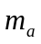. It is also directly proportional to the vehicle speed. Using Newton's Laws, the engine angular velocity is given as the solution of
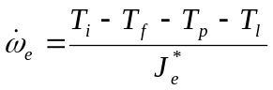, (14)

where 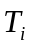 is the engine indicated torque, 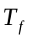 is the engine friction torque, 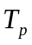 is the engine pump torque, 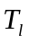 is the load torque, and 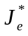 is the effective engine inertia. The torque variables in Equation 14 represent a variety of forces acting on the vehicle. represents the gross power generated by combustion in the engine cylinders. includes internal friction in the engine and power train while accounts for losses in the torque converter. The load torque is dependent on a number of factors including the amount of pressure on the brakes, the rolling resistance of the vehicle, and aerodynamic drag. The effective engine inertia is a gear dependent constant given by
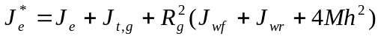, (15)

where 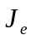 is the engine and torque converter inertia, 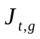 is the transmission inertia in gear (a gear dependent constant), 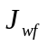 and 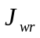 are the combined inertias of the front and rear wheels respectively, and  is the mass of the vehicle. The equation yielding the engine indicated torque is
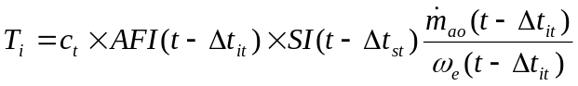, (16)

where 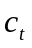 is the engine torque constant (the maximum torque capacity of an engine for a given air mass and engine speed), 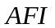 is the normalized air fuel influence function, 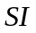 is the normalized spark influence function, 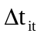 is the intake-to-torque production delay, and 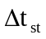 is the spark-to-torque production delay [1]. Assuming negligible time delays associated with engine power production, Equation 16 simplifies to
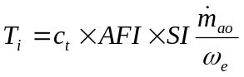. (17)

The normalized air fuel influence function is directly dependent on the AFR and is given by
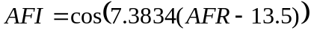. (18)

models the effect that ignition spark timing has on the engine torque production. The normalized spark influence function is given by
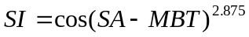, (19)

where 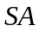 is the spark advance/retard from top dead center and the constant 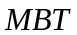 is the minimum spark advance for best torque [2]. Now that the engine's torque generation has been studied, the sources of energy loss are analyzed. The engine friction torque has been approximated from empirical data and is given by
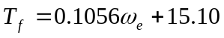 [2]. (20)

The torque converter's torque in converter mode is given by
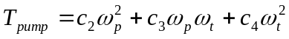, (21)
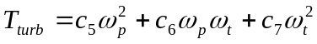 , (22)

where 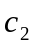 through 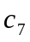 are constants. As the converter locks and transitions to fluid coupling mode, the torques become equal and are given by
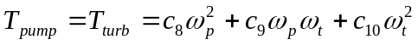, (23)

with 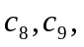 and 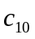 as constants. Since the pump rotates at the engine angular velocity and the turbine rotates as at the same rate as the pump in fluid coupling mode, the torque equation simplifies to
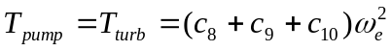. (24)

The final torque in the engine angular velocity differential equation, the load torque, is given by
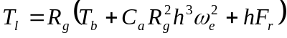, (25)

where 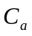 is a constant accounting for the aerodynamic drag coefficient and the constant 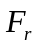 is the combined rolling resistance of the wheels.

The final state variable, the brake torque, is now analyzed. Unlike the other states, the brake torque is described by the following linear differential equation:
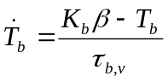. (26)

The brake torque constant of proportionality, 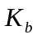, is directly related to the sensitivity of the brakes to pressure from the brake pedal. 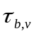, the brake system time constant, models the delay between pressure on the brake pedal and the application of the brake pads to the wheels.
Chapter 4 - Linearization, Discretization, and the Extended Kalman Filter for Vehicle Modeling

The Kalman Filter is a mathematical tool that estimates state information from noisy measurements. Although the filter maybe formulated in different ways, this thesis will focus on the computationally-efficient recursive form. This chapter will introduce the Kalman Filter and discuss its governing equations. In the next section, the Extended Kalman Filter (EKF) will be presented and its application to the research conducted in this thesis will be explained. The following sections will discuss specific implementation methods.

4.1 Kalman Filter for Linear Model
The classical Kalman Filter is a discrete-time, time domain filter used to estimate the states of linear, dynamic systems. Each iteration, it predicts the next state of the system using all past observations, receives a new observation corrupted by noise, then makes a corrected estimate of the system's state by comparing the new observation to all past observations. The filter models each state transition as
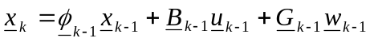, (27)

where is the state vector, is the state transition matrix, 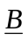 is the control-input matrix, is the control vector, 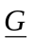 is the noise-coloring matrix, and 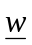 is the process noise. The state transition matrix describes how the system states change when no external inputs are applied. It is a significant indicator of the system's stability *** (eigenvalues on left side then stable, converges). The transition matrix has the following properties:
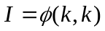, (28)
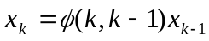, (29)
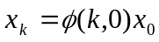, (30)
, (31)
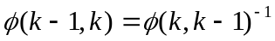 [Gelb]. (32)

The control-input matrix controls the effect of the inputs on the states. The noise-coloring matrix shows how noise affecting one state will create more noise on another state. The process noise is a vector of independent, white, normally-distributed random variables with zero mean and covariance defined by the matrix 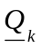. The process noise models state variations in a system (i.e. a rolling vehicle's velocity varies slightly depending on the number of bumps on a road). Usually, the sources of variation are not large enough to warrant a more complex model so they are treated as noise. The Kalman Filter models each observation as
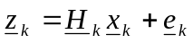 (33)

where 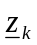 is the observation vector, 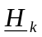 is the observation matrix, and 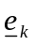 is the observation noise vector. The observation matrix converts the states to the value of the parameter observed. Although the states are being estimated, the state may not be directly observable so another physical quantity may be observed instead (i.e. using a thermocouple to observe voltage as an indicator of the temperature). The observation noise, like the process noise, is a vector of independent, white, normally-distributed random variables with zero mean and covariance 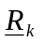. The observation noise models variations in sensor measurements. The process and observation noises have the following properties:
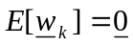, (34)
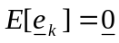, (35)
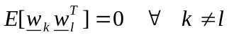, (36)
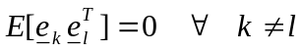, (37)
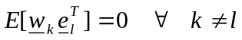. (38)

Before the Kalman Filter may begin estimating, the noise covariances and states must be initialized. The certainty of the initial state 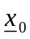 is reflected in 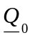. The Kalman Filter uses this value to decide how to correct its estimate during the correction step. The certainty of the observations is reflected in matrix 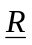. Since the observations are assumed to be statistically independent of each other, the certainty of one observation is no better than any other so is constant.

4.1.1 Prediction
The Kalman Filter predicts the next state of the system by making the best possible estimate at the current iteration. The best possible estimate is characterized by minimizing the mean squared error of the prediction. Since the noise is normally distributed, the optimal prediction is given by
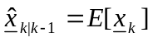. (39)

The equation shows that the predicted state estimate is the expectation or mean value of 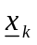. Since the expectation is a linear operator and the expectation of a deterministic variable is equal to that variable, the substitution of the state equation (Eqn. 27) into the prediction equation (Eqn. 38) yields
. (40)

Since the process noise is defined as having zero mean, the final form of the prediction equation is
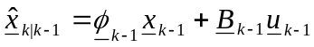. (41)

After making the state prediction, the filter determines the accuracy of the estimate using the covariance of the prediction state error. The prediction state error is defined as
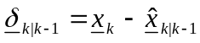, (42)

and its corresponding covariance during the prediction stage is given by (should I show the derivations for the equations in this section?)
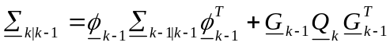. (43)

The Kalman Filter recalculates this quantity in the correction step using observation information.

4.1.2 Correction\Update
The Kalman Filter determines its corrected estimate by comparing the prediction to the observation. When the prediction state error is very low, the filter's corrected estimates are heavily influenced by the predicted estimates rather than the observation information. The influence is instead given to the observations when the prediction state error is high. The Kalman Filter's corrected estimate is given by
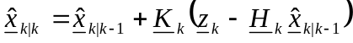, (44)

where 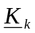 is the Kalman gain matrix and the quantity 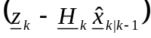 is defined as the innovation. The Kalman gain matrix determines whether the predicted estimate or observations are given more influence in the corrected estimate. The optimal gain is given by
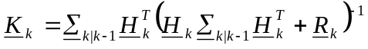 , (45)

where the term 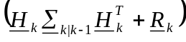 is the covariance of the innovation. The gain is considered optimal because it minimizes ***. Once the corrected estimate is found, the predicted state error is calculated by
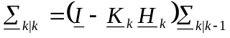. (46)

4.2 Extended Kalman Filter
The EKF is a generalized form of the classical Kalman Filter used to estimate the dynamics of nonlinear systems. The formulation of the EKF presented here is based on [Mendel]. It relies on two models, one nonlinear, another linear, as opposed to only a linear model used in the classical Kalman Filter. The nonlinear model is used directly in the prediction stage. In the correction stage, a linearization is performed on the nonlinear model around the previous corrected estimate to obtain a set of linear perturbation equations. The classical Kalman Filter correction equations are then used as a basis for the EKF correction equations. The EKF state and observation equations are given by
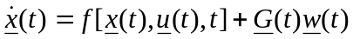, (47)
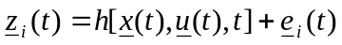, (48)

respectively, where 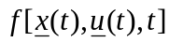 and 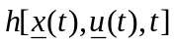 are functions of the state vector, the control vector, and either implicitly or explicitly a function of time. It is also assumed that both  and are continuous and continuously differentiable with respect to all elements of the state and control vectors. The state and control vectors are assumed to be continuous while the process noise is assumed to be a continuous, white noise process. The observations in Equation (ONE RIGHT ABOVE) are treated as being obtained at discrete intervals. The process and observation noise covariances are given in the equations
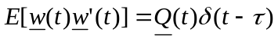, (49)
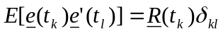, (50)

where 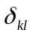 is defined as the Kronecker delta function. It is important to note that the quantity 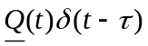 and 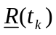 are the covariance matrices while 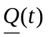 can be referred to as an intensity matrix [Mendel]. The noises also have the same characteristics shown in Equations (SET OF NOISE PROPERTIES) for the classical Kalman Filter: they have zero mean, are uncorrelated to themselves in time, and are uncorrelated to each other in time.

The EKF linearizes the nonlinear equations to obtain a set of linear perturbation equations. In section 4.3, some linearization methods are discussed. The EKF equations presented in this chapter are based on a first-order Taylor series expansion of the nonlinear equations for derivation of the linear perturbation equations. The linear perturbation state equation is given by
, (51)

where 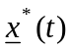 and 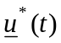 are defined as the nominal state and control vectors respectively. For the first iteration, these values are none other than the initial conditions. For successive iterations, the corrected estimates of the previous iteration are assigned as nominal values. The term 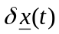 is defined as
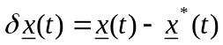. (52)

It is necessary for the nominal value to provide a good approximation to the actual value, otherwise, the linear perturbation equations will not adequately model the true behavior of the system. The term 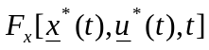 in Equation 46 is defined as
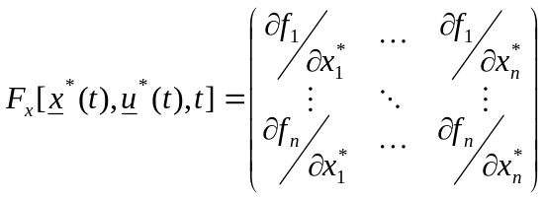, (53)

and the term 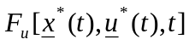 is defined as
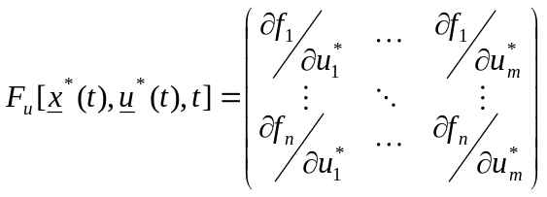, (54)

where is the number of state variables, and is the number of control variables. The partial derivative used in Equation 52 is defined as
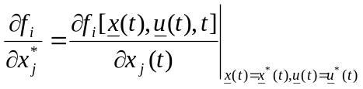. (55)

In Eqn. 53, the partial derivative is similarly defined as
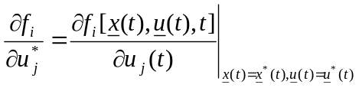. (56)

Repeating the linearization on the nonlinear observation equation yields the following linear perturbation observation equation:
. (57)

Now, to convert the perturbation state and observation equations to a form that is applicable to the recursive EKF equations, the equations need to be discretized.

The discretization is performed by first finding the solution of the linear perturbation state equation (Eqn. 46). The equation will be solved by first finding the homogenous solution, then the particular solution, then proceeding to find the complete solution. Removal of the inputs and noise yields the following homogeneous differential equation:
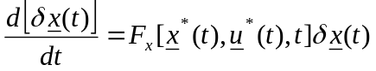. (58)

By utilizing

The discrete perturbation equations are given by
, (59)
, (60)

where

4.2.1 Prediction

4.2.2 Correction\Update
The filter produces good results when the system is only slightly nonlinear. When the system is highly nonlinear, the EKF can suffer from convergence problems and another form of the Kalman Filter may be preferable.

4.3 Numerical Integration Techniques
Numerical integration techniques are a suitable alternative to basic analytical integration in situations where certain nonlinear equations make finding analytical solutions impossible. In this section, the Euler and Runge-Kutta methods are examined.

4.3.1 Euler Method

4.3.2 Runge-Kutta Method

4.4 Discretization and Linearization Methods (162 Grewal)

Chapter 5 - Vehicle Network
This chapter will

5.1 Wireless Networking Technologies (VANETs)

5.2 Cooperative Vehicle Optimization

5.2.1 Sparse Traffic

5.2.2 Dense Traffic

Chapter 6 - Stability
This chapter will analyze the stability of the vehicle state equations. The results

6.1 Vehicle Model Stability

6.1.1 Equilibrium Points

6.1.2 Limit Cycles

6.2 Vehicle Optimization Algorithm Stability

Chapter 7 - Simulation Results

This chapter will present the results of simulations performed on the vehicle model and the network of vehicles. The first few sections will explain how certain constants

7.1 Vehicle Model Parameters
- T
- Mair
- How did you choose the EKF update frequency? (separate section?)
Why did you set parameters as such. Validate assumptions and show derivations for T, Mair….

7.2 Determining the Brake Constant of Proportionality
how Kb was determined

7.3 Determining Deceleration as a Function of Brake Angle

7.4 Simulations of Sparse Traffic Optimization Algorithm
- for the intersection topology and the vehicles. The topology is a flat, two-dimensional space with no elevation modeled after an intersection.
Chapter 8 - Conclusions
- Talk about future research topics
- more recent, more detailed mechanical model (hybrid)

Chapter 9 - References
[1] Berkeley PATH engine paper
[2] Supplemental Berkeley engine paper
[Mendel]
[Gelb]
[Grewal]
[Jazwinski]
[Ch8 Notes]

